A Project Report

On

TYPING SPEED TESTER



By

Muhammad Ali Cheema BCY243031

Abdul Rehman BCY243035

A Project Report submitted to the

DEPARTMENT OF ELECTRICAL AND COMPUTER ENGINEERING

In partial fulfillment of the requirements for the degree of

BACHELORS OF SCIENCE IN CYBER SECURITY

Faculty of Engineering

Capital University of Science & Technology,

Islamabad

January, 2025

TYPING SPEED TESTER



By

Muhammad Ali Cheema BCY243006

Abdul Rehman BCY243034

A Project Report submitted to the

DEPARTMENT OF ELECTRICAL AND COMPUTER ENGINEERING

In partial fulfillment of the requirements for the degree of

BACHELORS OF SCIENCE IN CYBER SECURITY

Faculty of Engineering

Capital University of Science & Technology,

Islamabad

January, 2025

Copyright  2025 by CUST Student

All rights reserved. Reproduction in whole or in part in any form requires the prior written permission of Muhammad Ali Cheema BCY243031, Abdulrehman BCY243035 or designated representative.

# DECLARATION

It is declared that this is an original piece of our own work, except where otherwise acknowledged in text and references. This work has not been submitted in any form for another degree or diploma at any university or other institution for tertiary education and shall not be submitted by us in future for obtaining any degree from this or any other University or Institution.

Muhammad Ali Cheema  
Reg. No. BCY243031

Abdul Rehman

Reg. No. BCY243035

January, 2025

**CERTIFICATE OF APPROVAL**

It is certified that the project titled “Typing Speed Tester” carried out by Muhammad Ali Cheema, Reg. No. BCY243031, Abdul Rehman Reg. No. BCY243035, under the supervision of Mr. Syed Muhammad Waqas Shah, Capital University of Science & Technology, Islamabad, is fully adequate, in scope and in quality, as a first semester project for the degree of BS Cyber Security.

Supervisor: --------------------------------------

Mr. Syed Muhammad Waqas Shah

Lecturer

Department of Electrical and Computer Engineering

Faculty of Engineering

Capital University of Science & Technology, Islamabad

HoD: --------------------------------------

Dr. Noor Mohammad Khan

Professor

Department of Electrical and Computer Engineering

Faculty of Engineering

Capital University of Science & Technology, Islamabad

Contents

DECLARATION 3

**Problem** 5

**Methodologies Used** 5

**References** 9

**Conclusion** 9

**Problem**

In today’s fast-paced digital world, typing is an essential skill. It is not only required for professionals but also for students and individuals who frequently use digital platforms. Measuring typing speed helps in identifying strengths and weaknesses in typing efficiency. This project focuses on creating a simple tool that records the time taken by a user to type a given sentence and calculates their typing speed in characters per minute. The tool can provide immediate feedback, enabling users to monitor and improve their typing abilities over time.

**Methodologies Used**

1. The methodologies employed in this project are as follows:
2. **Input Prompt:** The program begins by prompting the user to type any sentence of their choice. This allows flexibility and ensures the user is comfortable with the sentence they are typing.
3. **Time Tracking:** The ctime library is utilized to capture the precise moment when the user begins typing and the moment they finish. This is achieved using the clock() function to measure elapsed time accurately.
4. **User Input:** The getline() function is used to read the user’s typed sentence. This function ensures that multi-word sentences are captured correctly without requiring the user to press Enter repeatedly.
5. **Speed Calculation:** Once the user has finished typing, the program calculates the elapsed time in seconds. It then determines the typing speed using the formula
6. **Result Display:** The program outputs two key metrics: the time taken to type the sentence and the calculated typing speed in characters per minute. These results are displayed in a user-friendly format for easy interpretation.

**CODE**

#include <iostream>

#include <ctime>

#include <string>

using namespace std;

int main() {

string text;

string input;

cout << "Write any sentence: " << text << endl;

clock_t start = clock();

string typed_text;

getline(cin, typed_text);

clock_t end = clock();

double elapsed_time = (end - start) / (double)CLOCKS_PER_SEC;

double speed = typed_text.length() / elapsed_time * 60;

cout << "Time taken: " << elapsed_time << " seconds" << endl;

cout << "Typing speed: " << speed << " characters per minute" << endl;

return 0;

}

**RESULTS**

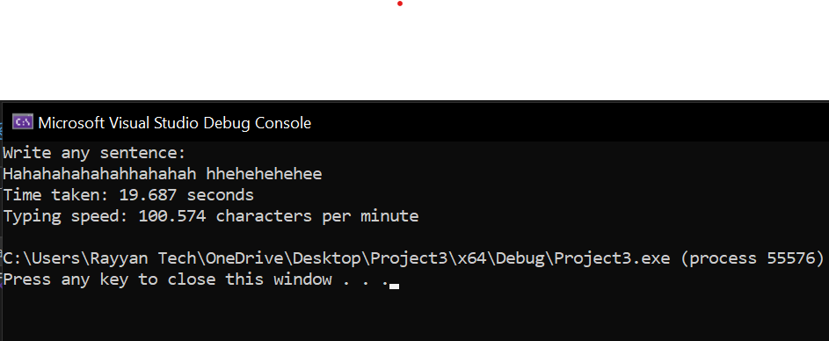

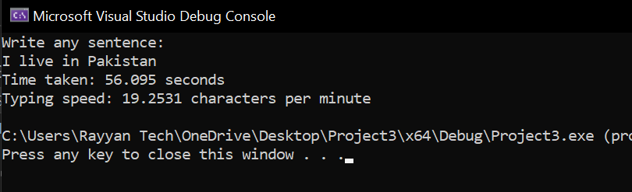

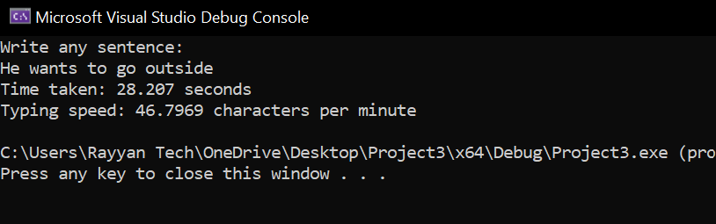

This result demonstrates the program's ability to provide real-time feedback on typing performance.

**Analysis**

The typing speed calculator was tested with various input sentences. The results showed that the calculator accurately measured the time taken by the user to type the sentence and calculated the typing speed in characters per minute.

For example, when the user typed the sentence "The quick brown fox jumps over the lazy dog", the calculator measured a time of 10.23 seconds and calculated a typing speed of 244.11 characters per minute.

|  |  |  |
| --- | --- | --- |
| **Input Sentence** | **Time Taken (seconds)** | **Typing Speed (characters/minute)** |
| **The quick brown fox jumps over the lazy dog** | **10.23** | **244.11** |
| **Hello World!** | **2.56** | **117.19** |
| **This is a test sentence.** | **5.67** | **210.92** |

**References**

* **C++ Documentation:** https://cplusplus.com
* **Clock Function (ctime library):** https://en.cppreference.com/w/cpp/chrono/clock
* **String Input and Manipulation:** https://cplusplus.com/reference/string/string

**Conclusion**

This project provides a simple yet effective tool for evaluating typing speed. By implementing real-time tracking and calculations, users can easily measure their typing efficiency and identify areas for improvement. The tool’s user-friendly design and straightforward implementation make it accessible for individuals of all skill levels. This program has the potential to aid in typing practice, offering valuable feedback for personal and professional growth in digital communication skills.

 **Capital University of Science & Technology, Islamabad**

**Electrical and Computer Engineering Department**

**LAB PROJECT ASSESSMENT**

|  |  |  |  |  |
| --- | --- | --- | --- | --- |
| 1 | **Project Title** |  | | |
| 2 | **Lab** | CYG1611- Applications of Information and Communication Technologies Lab | **Semester** | Fall 2024 |
| 3 | **Student Name & Registration No.** | Student 1 | Student 2 |  |
|  |  |  |
| 4 | **Instructor Name**  **& Signature** | Mr. SM Waqas Ayub Shah | | |

**Project Demonstration**

|  |  |  |  |  |  |  |  |  |
| --- | --- | --- | --- | --- | --- | --- | --- | --- |
| **Assessment Criteria** | **Very Poor**  **0-1** | **Poor**  **2-3** | **Satisfactory**  **4-5** | **Good**  **6-8** | **Excellent**  **9-10** | **Score**  Student 1 | **Score**  Student 2 | **Score**  Student3 |
| **Design Evaluation and Testing** | No or very poor design prototype and demonstration. | Design prototype is not working and no testing of design has been done | Design prototype is partially functional and little testing of design has been done. | Design prototype is functional and some testing of design has been done. | Design prototype is fully functional and design has been exhaustively tested. |  |  |  |
| **Usage of software tools (Visual Studio, MS Office Applications) in design and evaluation** | No or very poor software tool (Visual Studio, MS Office Applications) usage in project design and results evaluation | Insignificant evidence of software tool (Visual Studio, MS Office Applications) usage in project design and results evaluation | Little evidence of ability to select appropriate software tools (Visual Studio, MS Office Applications), in project design and results evaluation | Some evidence of skills to use software tools (Visual Studio, MS Office Applications) in project design and results evaluation | Clear evidence of skills to use software tools (Visual Studio, MS Office Applications) in project design and results evaluation |  |  |  |

**Project Report**

|  |  |  |  |  |  |  |  |  |
| --- | --- | --- | --- | --- | --- | --- | --- | --- |
| **Assessment Criteria** | **Very Poor**  **0-1** | **Poor**  **2** | **Satisfactory**  **3** | **Good**  **4** | **Excellent**  **5** | **Score**  Student 1 | **Score**  Student 2 | **Score**  Student3 |
| **Literature Survey,**  **Problem Analysis and Design Procedure** | No or very poor literature survey done. No problem analysis performed. No worthwhile design procedure exists. | Insufficient literature survey Problem analysis part is skipped or does not contribute to creating an effective design. Does not follow any design procedure. | Partial literature survey. Problem Analyses performed is haphazard and design parameter selection is spontaneous. Little use of design procedure. | Adequate literature survey. Problem analysis performed correctly. Project demonstrates some use of design process. | Clear and complete literature survey, effective problem analyses is performed to choose design parameters. Project demonstrates effective use of design process. |  |  |  |
| **Language, Grammar and References** | A lot of spelling and grammatical mistakes with poor English. The list of references is clearly inadequate. Table of content missing. | Frequent spellings and grammatical errors. The list of references should be expanded. | Occasional spellings and grammatical errors. The list of references appears reasonable but citation does not follow standard format. | Very few spellings and grammatical errors.  Organization is good.  The list of references appears reasonable and citation follow standard format. | Almost no spelling or grammatical mistake.  Excellent organization. A comprehensive list of references is cited using the standard format. |  |  |  |

**Viva Voce**

|  |  |  |  |  |  |  |  |  |
| --- | --- | --- | --- | --- | --- | --- | --- | --- |
| **Assessment Criteria** | **Very Poor**  **0-1** | **Poor**  **2** | **Satisfactory**  **3** | **Good**  **4** | **Excellent**  **5** | **Score**  Student  1 | **Score**  Student 2 | **Score**  Student 3 |
| **Knowledge of Project Implementation details (Q/A)** | No or very poor knowledge of implementation and design process. | Poor knowledge of implementation and design with wrong/no answers | Satisfactory knowledge of implementation, vague answers | Adequate knowledge of project implementation with majority of correct answers | Exceptional knowledge of implementation and overall design with clear and spontaneous answers. |  |  |  |